# Lab 1 – SDLC, Modelling and Academic Integrity

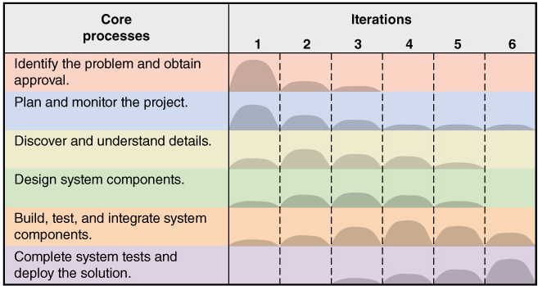

Consider the following scenario:

**This case study will be used throughout the rest of the laboratories.**

Stratosphere Pharmacies is an Australia-wide chain of chemists with stores in every major retail hub of prominent cities. In addition to its fledgling bricks and mortar stores, Stratosphere Pharmacies has a significant online commercial presence. Customers can browse and purchase items from the comfort of their own homes. To keep up with the latest technology and ecommerce business models, Stratosphere Pharmacies is contracting your software development company to extend upon their online capabilities.

Stratosphere Pharmacies wants to launch an online service to provide drone-based delivery of pharmaceutical products and doctors’ prescriptions. Customers can purchase a small weighing item (such as aspirin) or lodge a prescription online. Stratosphere Pharmacies will then check whether the product is part of the deliverable stock if it is a regular pharmacy item. Alternately, if the order is for a doctor’s prescription, Stratosphere Pharmacies will undertake due diligence before filling the order (i.e., check for authenticity, medical history, government compliance, etc.).

A drone will then deliver the order to the home address of the customer. The customer must be present at the location during delivery and have an authorised Stratosphere Pharmacies geo-located app. The app verifies the customer’s identity and physical presence before the drone releases the delivery at the destination. Customers can track the status and location of their delivery, access a transaction log, view doctor information, and leave feedback about their experience.

You are assigned as Stratosphere Pharmacies’ project manager and allocated $100,000 for building this project. You will do various exercises based on your role and the project throughout our labs.

1. Identify the following components for the Stratosphere Pharmacies information system:

|  |  |
| --- | --- |
| 1. Hardware  * Networking equipment * Mobile phone * Computers * Drone * GPS * Sever  1. Software  * Website * database management system * E- commerce * Software, * Geo-location app * Customer management software * Security system  1. Data  * Customer account * Information, product data * Medical history data * Delivery history data  1. People  * Project manager * ICT people(web app developers、database administrators) * Customer support representatives * Marketing and sales teams * Pharmacists  1. Procedures | fig02_03 |

* Product search and order placement procedures
* Medicare and perscription procedures
* Data collection procedure
* Data analysis procedure

1. During the workshops and assessment for this course, you will need to develop modelling diagrams that capture various facets of your Assignment information system. There are numerous modelling tools available. Three significant tools include:

* Lucidchart (<https://www.lucidchart.com/pages/>)
* draw.io (<https://www.drawio.com/)>
* Microsoft Visio (available on all campus lab computers)

You are free to choose whichever one of these tools you like. However, you must select only one from this list and use it exclusively throughout the course. Workshops will be demonstrated using Lucidchart.

Create a free (Educational Licence) Lucidchart or draw.io account.

1. Using your nominated drawing software, recreate the following image to the best of your ability with the tools available:



* As the follow:

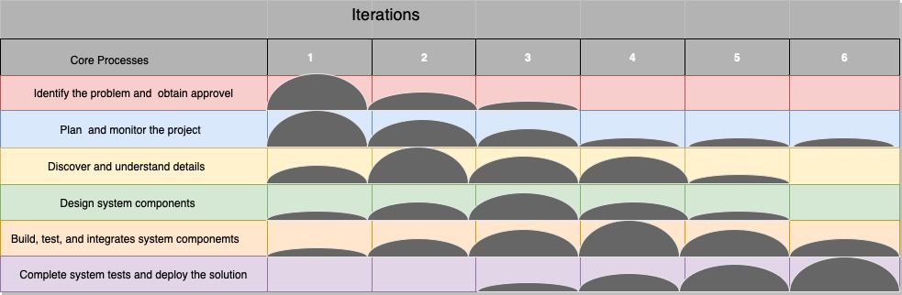

1. Undertake the **Academic Integrity Training Quiz** on the Course Site. Records will be maintained on whether this quiz has been completed. **You must obtain a minimum of 80% to pass the quiz.**

* DONE

1. Read **Assignment 1**, find a teammate and think of a topic. Register yourself in an Assignment Group on the Course Site:
   1. Click the “People” option in the left side menu, then click on the “Groups” tab to display the available groups.
   2. Click on one of the listed Groups and join it. **Ensure your assignment teammate also joins the same group.**

Help page on joining Groups in Canvas:  
<https://community.canvaslms.com/t5/Student-Guide/How-do-I-join-a-group-as-a-student/ta-p/468>

* DONE GROUP 66